**Bootstrap**

* Bootstrap is an open source toolkit for developing Mobile and Web Applications with HTML, CSS and JavaScript.
* It provides a repository [library] that helps developers to build complex HTML, CSS and JavaScript page with less logic and markup.
* It provides pre-defined CSS classes and stylesheets, which you can use for any HTML page.
* Bootstrap even provides templates for web and mobile application.
* Bootstrap also provide premium features.

[www.getbootstrap.com](http://www.getbootstrap.com)

* Latest version 4.5
* Bootstrap 5 is coming [not stable yet]

**Setup Environment for Bootstrap**

* Download “Node.js” on your computer.
* Node.js is required for Package Manager.
* Package Manager is a tool used to install and maintain packages [library] for project.
* There are several package managers
  + NPM
  + Yarn
  + Bower
  + RubyGems
  + NuGet
* Download Node.js for NPM

<https://nodejs.org/en/download/>

* Test Node.js version from command prompt

> node -v

> npm -v

**Install Bootstrap for your project with NPM:**

* Open your project in VS code
* Open Terminal [Ctrl + `]
* Type the following command  
  > **npm install bootstrap**
* Bootstrap library is added into a folder “**node_modules**”

**Install jQuery for your project with NPM:**

* jQuery is a library used by bootstrap for creating complex interactions.
* To install jQuery type the following command  
  > **npm install jquery**
* jQuery library is added into “node_modules”

**The basic files required for bootstrap templates from “bootstrap and jQuery” are:**

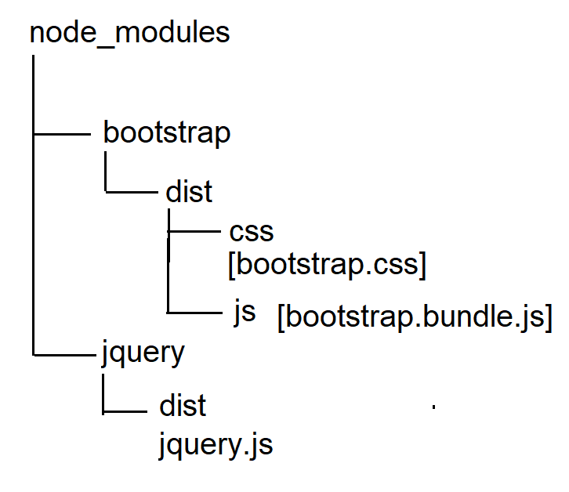

* bootstrap.css
* jquery.js
* bootstrap.bundle.js

**Note:** Any jQuery file of bootstrap must be defined only after “jquery.js”

* A developer has to know about different types of CSS classes provided by **bootstrap.css** and different types of attributes provided by **bootstrap.bundle.js**
* A developer can extend existing bootstrap classes and customize according to his requirements.

Ex:

<!DOCTYPE html>

<html>

<head>

<title>Demo</title>

<link rel="stylesheet" href="../node_modules/bootstrap/dist/css/bootstrap.css">

</head>

<body class="container">

<h1 class="text-primary text-center">Welcome to Bootstrap</h1>

<button class="btn btn-outline-primary">Submit</button>

</body>

</html>

**Bootstrap Containers**

* Containers are used for basic layout design.
* Containers are defined with margin and padding.
* Containers are controller with “@media()” feature, which can make your content responsive.
* Bootstrap provides 3 different container classes
  + .container
  + .container-fluid
  + .container-sizes[sm, md, lg, xl]

|  |  |
| --- | --- |
| **Container Class** | **Resolution** |
| .container | Min 540px – Max 1200px - width |
| .container-sm | Min 540px – max 1140px [mobile] |
| .container-md | Min 100% - max 1140px [tab] |
| .container-lg | Min 100% - max 1140px [laptop] |
| .container-xl | Min 100% - max 1140px [desktop] |
| .container-fluid | Min 100% - max 100% [responsive] |

Ex:

<!DOCTYPE html>

<html>

<head>

<title>Demo</title>

<link rel="stylesheet" href="../node_modules/bootstrap/dist/css/bootstrap.css">

<style>

div {

border:2px solid darkcyan;

margin-top: 10px;

}

</style>

</head>

<body>

<div class="container">

Container

</div>

<div class="container-sm">

Container-sm

</div>

<div class="container-fluid">

Container Fluid

</div>

</body></html>